Renju lesson on April 11, 2002

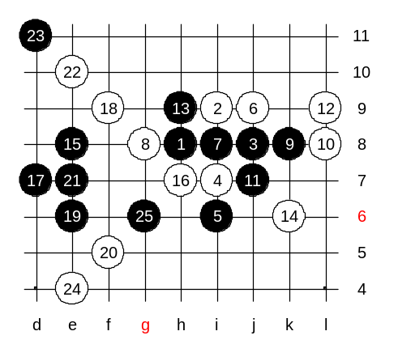
Hello everyone! Welcome to Online Renju Class. Last time we finished checking the 6-h9. Is there any difference between 6-h9 and 6-j9? Is there any difference that influences the winning pattern that we learned last week? Can you show me the variant where black attack will fail because of the closer board edge?

Anyway, to make it simpler, black has a VCT from 6th move.
A nice space attack. We do not need to go any further from here, do we?

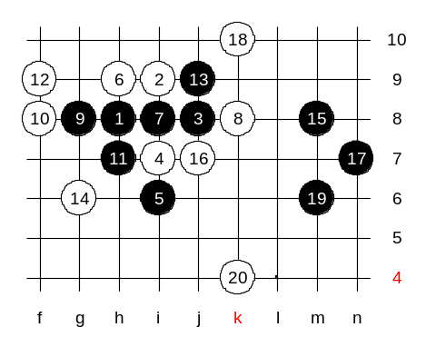

Note that same win doesn’t work in case of 6-h9.

So, before making the 7th move, be sure you do not end up in wrong corner.

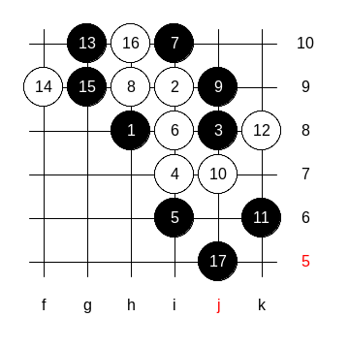
We have one last 6th move to check. 6th - passive move but quite tough. Black's 7-th move is too obvious. Black has a good balance of stones. Now, depending on white's block, black will attack on the opposite side. I will demonstrate some possible developments according to my book. According to the analysis, white was making the strongest moves, but still lost.

Now, I explain why white chose those blocks.
And what would happen if white played elsewhere. About the 16th move, we check the case 16-g8. Other 16th moves are out of our interest.

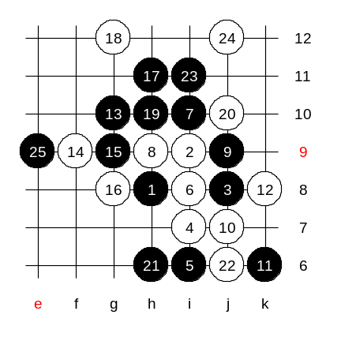

Black uses the lower side connection successfully.

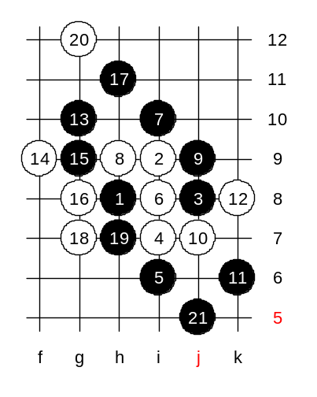

White is now forced to play 18-g7, in order to break the lower side connection that you just saw before. But in that case black gets win below.

Let's say that white did not like that black played 13-g10.
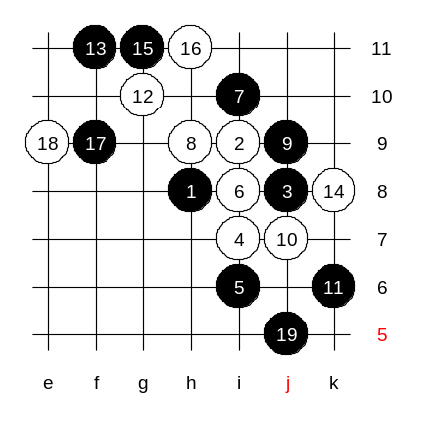
The idea of the four is to push black stones farther from each other and make the connection harder. Black's idea is to finalize the attack in j5. However, before playing to the best point, you remember the support rule. Black will have to try to create some supportive structures if possible, before going to the final attacking area. Who remembers this tactics? Maybe 15-g11 or 15-h11 is a good way to begin the support building. Many beginners to not have patience and try j5 immediately.
Black has created some structures by the 19th move, and now it may be good time to go j5 and enjoy the left side support.
Is black position now better compared to instant 15-j5?

